Greentrees Primary School

Parent/Carer Curriculum Newsletter

Panthers Class Teachers: Mrs Smith (Mrs Mills Wednesday)

Autumn Term 1 2026
(3/09/26 – 21/10/26)

Your child will be focusing on the following objectives this term with adaptations for different year groups:

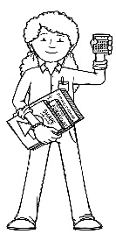  Being a Mathematician | If your child integrates for maths, please see the class they go to for their objectives. Year 6 Scorpions and Spiders  Mrs Smith will be teaching from the Year 2 curriculum objectives:  Multiplication and Division  - Equal groups  - Multiplication (x) symbol  - Using arrays  - 2x table including division  - Doubling and halving  - Odd and even numbers  - 10x table including division  - 5x table including division  Measurement – Money (if time)  - Recognise coins and notes; counting money pence and pounds  - Comparing amounts; making a pound  - Finding change
Being an Author – Writer  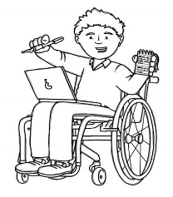 | - Writing to entertain – write a story  - To describe settings and characters  - Write in sequences of sentences using capital letters, full stops and conjunctions (Yr 2)  - Write using different tenses  - Use a range of sentence types with different clauses (Yr 5/6)  - Use fronted adverbials and speech marks (Yr 5/6)  - To edit and improve vocabulary  - Spelling/phonics activities by group using Spelling Shed and Common Exception Word lists
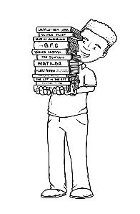  Being an Author – Reader | Children in Panthers class will have a school book to take home to practise reading which is levelled according to colour. They will have a reading for pleasure book which will stay in their tray. Children can also choose to read other books in the classroom. In groups children will look at a new text each week and use a range of skills. Our Year 6 readers will be reading, ‘The Boy at the Back of the Class by Onjali Rauf:  - Read and discuss an increasingly wide range of fiction, poetry, plays, non-fiction and reference books or textbooks  - Retrieve, record and present information from non-fiction  - Draw inferences such as inferring characters’ feelings, thoughts and motives from their actions and justifying inferences with evidence  - Predict what might happen from details stated and implied
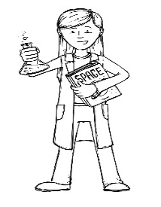  Being a Scientist | How can science help the vulnerable?  Materials and their Properties  - What are materials and their properties and how can they be grouped?  - Solids, liquids, gases  - What is solubility?  - How are mixtures separated?  - What are reversible and irreversible changes?
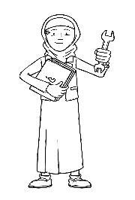  Being an Engineer  (Design Technology) | Design, make and evaluate for a purpose:  - Suitability of materials for everyday uses  - Evaluating products and new innovations  - Challenge: to create a homeless pack
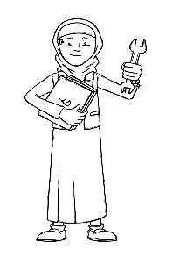  Being an Engineer  (Computing) | Computing Systems and Networks  - Connecting networks  - What is the internet?  - Sharing information  - What is a website?  - Who owns the web?  - Can I believe what I read?
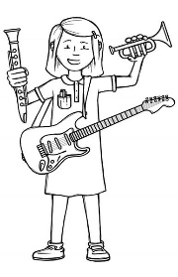  Being a Musician | Using our Charanga Creative Scheme we will be focusing on Soul as a genre and learning to sing ‘My Best Friend’. Through this we will:  - Listen and appraise a variety of soul pieces and artists  - Copy and clap back simple rhythms and improvise our own  - Introduce formal notation using crotchets and quavers  - Play 5 notes to accompany and improvise to the music using note names and notation on a stave  - Compose a piece in Ternary form using Music Notepad  - Improvise over a drone
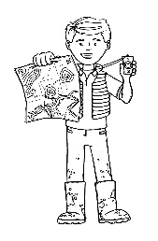  Being a Geographer | Not part of our enquiry this term
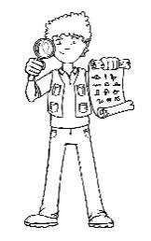  Being an Historian | Not part of our enquiry this term
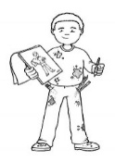  Being an Artist | Not part of our enquiry this term but we will continue to practise our drawing, colouring and painting skills.
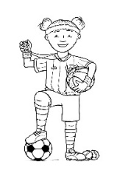  Being an Athlete | Get Set 4 PE: Ball skills  - Rolling and stopping a ball  - Hitting a target  - Dribbling a ball with feet/hands  - Kicking a ball  - Developing throwing and catching
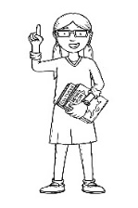  Being a Philosopher  (Religious Education) | Repentance  Why do Jewish families talk about repentance at New Year?  - Engage with meaning of repentance and saying sorry  - Enquire into idea of making new starts - Rosh Hashanah  - Explore repentance and forgiveness in story of Jonah and the whale  - Explore how Teshuvah is put into practice in everyday life  - Explore ways the Jewish community show repentance at Yom Kippur  - Evaluate  - Express
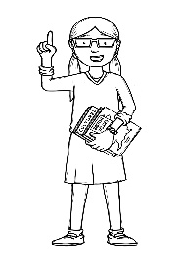  Being a Philosopher  (PSHE) | Being me in my world:  - Getting to know each other  - Our nightmare school  - Our dream school  - Rewards and consequences  - Our learning charter  - Owning our learning charter
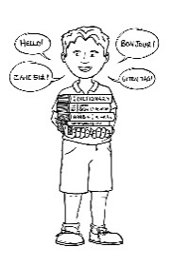  Being a Linguist  (Spanish) | Introduction to Spanish  Learn greetings and be able to introduce yourself  Learn about the country and be able to find it on a map

