Year 4 Home Learning - Complete one home learning task each week.
1. Roman Numerals. Can you make a Roman Numerals Hundred Square? You could even write out your times tables and division facts when you have made it!   | 2. Find out some facts about the Christian religion.   | 3. Plot on a map certain areas of the world where most meat is reared. For example, cattle for beef.   | Describe the setting of your favourite fictional story.  
  5. Make a dish using seasonal produce. | 6. Hold a family debate about your views on animal rights.   | 7. Plan a warm up for a PE lesson. You may be asked to coach the class!   | 8. Research some key rules of Netball. You could look at the footwork rules which can be tricky to master.  
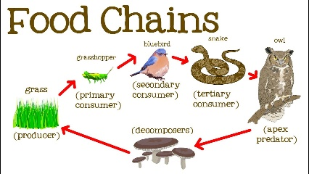  9. Construct a food chain and label producers, predators and prey | 10. Perform your favourite song to your family. If you’re feeling brave, send in a video!   | 11. Write a story.   | 12. Label the parts of the digestive system.  