Greentrees Primary School

Parent/Carer Curriculum Newsletter

Panthers Class Teachers: Mrs Smith, Mrs Mills (Thursday)

Spring Term 4 2026
(24/2/26 – 27/3/26)

Your child will be focusing on the following objectives this term with adaptations for different year groups:

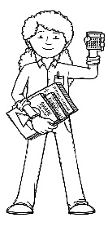  Being a Mathematician | If your child integrates for maths, please see the class they go to for their objectives. Year 4 Impalas, Year 5 Leopards, Year 6 Spiders  Mrs Smith will be teaching from the Year 2 curriculum objectives:  Addition and Subtraction  - Addition and subtraction across and from 10  - Subtract a 1-digit number from a 2-digit number  - 10 more/less  - Add and subtract 10s  - Add and subtract two, 2-digit numbers  - Number sentences
Being an Author – Writer   | Group 1: (Yr 5 objectives)  - Writing to entertain – write a story using ‘The Explorer’ Katherine Rundell  - Narrative • Recognising dialogue, action and description in narrative • Punctuating dialogue correctly and using reporting clauses • Using relative clauses and relative pronouns  - Adverbial phrases and fronted adverbials  - Planning a narrative extract • Writing a narrative extract, which includes dialogue, action and description • Describing setting and action • Editing and improving writing  - Punctuation: speech marks, brackets, dashes, commas  - Writing a non-chronological report  Group 2: (Yr 1 objectives)  - Writing to entertain – write a diary using first person  - Constructing sentences: use of capital letter and full stop  - Conjunction ‘and’ to join 2 clauses
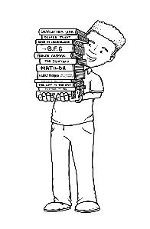  Being an Author – Reader | Children in Panthers class will have a school book to take home to practise reading which is levelled according to colour. They will have a reading for pleasure book which will stay in their tray. Children can also choose to read other books in the classroom. In groups children will look at a new text each week and:  - Read and discuss an increasingly wide range of fiction, poetry, plays, non-fiction and reference books or textbooks  - Retrieve, record and present information from non-fiction  - Draw inferences such as inferring characters’ feelings, thoughts and motives from their actions and justifying inferences with evidence  - Predict what might happen from details stated and implied
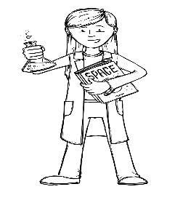  Being a Scientist | Mini Enquiry: How do we switch off?  Electricity:  - Common electrical appliances  - Construct simple electrical circuits  - Switches used to open and close a circuit  - Conductors and insulators
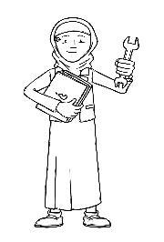  Being an Engineer  (Design Technology) | How do we switch off?  - Understand and use an electrical system within a product to incorporate a switch, bulb or buzzer  - Evaluate ideas and products to improve their work
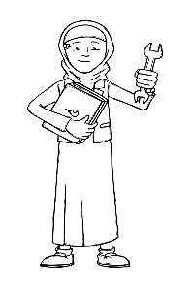  Being an Engineer  (Computing) | Computing (NCCE) – Sequencing Sounds using Scratch  - Programming sprites  - Sequences – joining blocks of code together  - Ordering commands/sequences  - Changing the appearance of my project  - Create a project
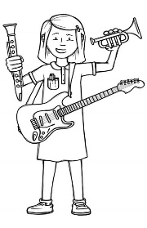  Being a Musician | Using our Charanga Scheme we will be focusing on the song ‘The Fresh Prince of Bel Air by Will Smith. Through this we will:  - Listen and appraise a variety of hip hop pieces  - Copy and clap back simple rhythms and improvise our own  - Introduce rhythm notation and rhythm grids  - Play notes to accompany and improvise to the music using note names and notation on a stave  - Compose with the music
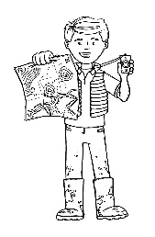
Being a Geographer

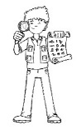  Being an Historian | - Finish enquiry on Maya
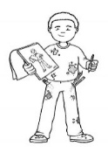  Being an Artist | • Use sculpture to develop and share ideas, experiences and imagination  • To develop a wide range of art and craft techniques using form and space  • To learn about the work of a range of artists, craft makers and designers, describing the differences and similarities between different practices and disciplines, and making links to their own work.
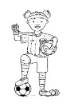  Being an Athlete | Horse riding  Soft cricket
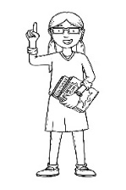  Being a Philosopher  (Religious Education) | What do Christians mean when they talk about the Kingdom of God?  Christians believe: • In living God’s way. Jesus summed this up with the Golden Rule: ‘In everything do to others as you would have them do to you.’ • God is King. • The Bible and the parables of Jesus teach the right way to live. • The Lord’s Christians want to be part of spreading God’s kingdom on earth.
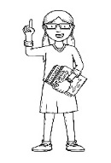  Being a Philosopher  (PSHE) | Healthy Me (Jigsaw Scheme)  - Fit and healthy  - Food and energy  - Drugs  - Being safe and getting help  - My amazing body
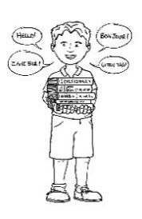  Being a Linguist  (Spanish) | Introduction to Spanish  Learn greetings and be able to introduce yourself  Numbers

