Greentrees Primary School

Parent/Carer Curriculum Newsletter

Year: 2 Class Teachers: Mrs McKay & Miss Cridge
Autumn Term 2 2025
(03/11/25 – 19/12/25)

Your child will be focusing on the following objectives this term:

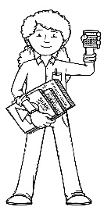  Being a Mathematician | - To know number bonds to 100 e.g. 90+10, 80+20 etc  - Add and subtract 1s from a 2 digit number  - Add by making 10  - Add three 1 digit numbers  - Add and subtract 10 from a 2 digit number by bridging the ten  - Add and subtract two 2 digit numbers bridging the 10s.  - Answering mixed addition and subtraction number sentences  - Compare number sentences and find missing numbers  - Recognise 2D and 3D shapes  - To be able to identify sides, vertices and lines of symmetry on 2D shapes  - To be able to draw 2D shapes  - To be able to count faces, edges and vertices on 3D shapes  - To be able to sort and compare 2D and 3D shapes  - To make patterns with 2D and 3D shapes
Being an Author – Writer  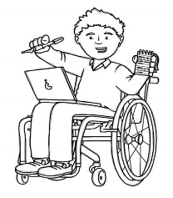 | - Write simple, coherent narratives  - Demarcate sentences using full stops and capital letters  - To know what a paragraph is  - To use co-ordinating and sub-ordinating conjunctions in writing  - To recognise and use different sentence types (statement, command, exclamation & question)  - To write in the present tense  - To write in the 3rd person  - To begin to independently edit learning  - Ongoing learning will include spelling rules, grammar and sentence work
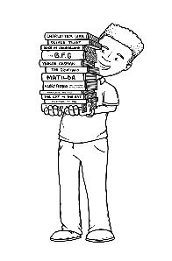  Being an Author – Reader | - Extract meaning from the text while reading with less dependence on illustrations  - Use punctuation and text layout to read with a greater range of expression and control  - Read unfamiliar words using their sound knowledge  - Approach different genres with increasing flexibility  - To explain what has happened so far in a text they are reading  - Learning, recapping and using phonics sounds in reading  - Ongoing learning will include phonic knowledge, spelling rules, grammar, sentence work and reading comprehension skills
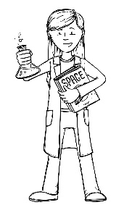
Being a Scientist

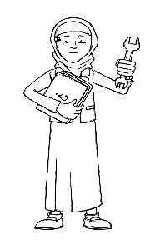  Being an Engineer  (Computing) | Unit 2 – Creating media: Digital Photography  - To know that many devices can be used to take photographs  - To know that a photograph can be taken landscape or portrait  - To know how to compose photographs and know what tools can used to change the way that a photograph looks.
Being an Engineer
(Design Technology)

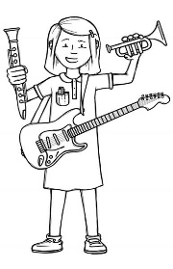  Being a Musician | Nativity  - Children will learn and practise songs from this year’s nativity play.
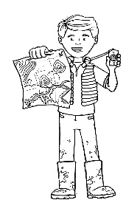  Being a Geographer | Where is water in the world?  - To name and locate the 7 continents and 5 oceans  - Identify hot and cold areas of the world  - Locate areas of water on a simple map  - Know the 5 rivers of Salisbury  - To find out about the human and physical geography of Salisbury  - Understand the human and physical geography of a non-European country.
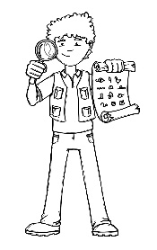
Being an Historian

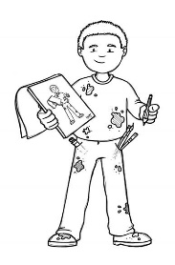  Being an Artist | Where is water in the world (and why is it important)?  - To describe why colours may be used for different purposes  - To explore a range of brush sizes
Being an Athlete  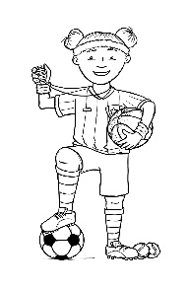 | Real PE Unit 4 (Creative)  I can begin to compare my movements and skills with those of others.  I can select and link movements together to fit a theme.  Fundamental Movement Skill Focus  Coordination: Ball Skills  Counter Balance: With a Partner  Get Set 4 PE – Target games  Physical: roll, overarm throw, underarm throw, strike, dodge, jump  Social: congratulate, support others, co-operation, kindness  Emotional: manage emotions, honesty  Thinking: identify areas of strength and areas for development, select and apply, comprehension, decision making
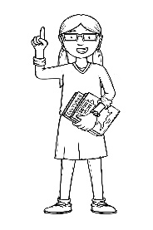  Being a Philosopher  (Religious Education) | Key Question: Why was Jesus given the name ‘saviour’?  - Religion: Christianity
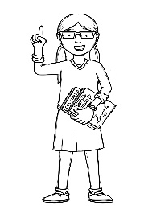  Being a Philosopher  (PSHE) | - Celebrating Difference (Jigsaw)

Other Information:

Home learning will be given out on a Thursday. If home learning isn’t given on a Thursday it is expected that children will complete a task from the ‘ongoing’ list of the home learning policy. These task include:

- Listening to adults read stories
- Reading (from reading book and other books/own literature – we recommend no more than 10 or 15 minutes). Please record and sign the ‘Reading Record’
- Using your reading bookmark to answer comprehension questions about a story. Please record and sign the ‘Reading Record.’
- Reading and spelling from word cards
- Mathletics (once allocated)

Children should be practising their spellings and reading regularly at home. There will be two PE sessions a week. Please ensure your child has a complete labelled PE kit, including some tracksuit bottoms for outdoor games.

Year 2 Team

